**User:**

I am a Mechanical Designer, proficient in SolidWorks drafting, and a recent graduate of the University of New South Wales. I would like you to act as both a knowledgeable designer who can provide me with design expertise and a professional engineering designer who can act as a technical advisor to me when I have complex questions.

The equipment must comply with Australian Standards for Electrical Equipment. The design should be compact to fit into the limited urban space where the installation is specified. Considering the budget of A$50,000, we should prioritise durable materials, balancing cost and longevity.

For this project, I favoured a bio-inspired design approach, using principles found in nature to optimise energy harvesting.

Based on the above background, I will be designing an energy harvesting device.

The energy harvesting device shall require three key modules:

1. The energy accumulation module functions to derive energy from an external source outside the energy harvesting device.

2. The energy storage module functions to store the accumulated energy inside the energy

harvesting device.

3. The energy utilization module utilizes the harvested energy to power other small devices such as sensors, heating/cooling devices, actuators, and low-power devices.

Please give me as many and reasonable and complete designs as possible.

**GPT:**

Designing an energy harvesting device that aligns with your specifications and the bio-inspired design approach is an exciting challenge. The design will focus on compactness, compliance with Australian Standards for Electrical Equipment, and a budget-conscious approach with durable materials. Here’s a conceptual outline for the three key modules of your energy harvesting device:

1. **Energy Accumulation Module**:
   * **Design Inspiration**: Mimic natural phenomena like photosynthesis or piezoelectric effects observed in certain biological structures.
   * **Technology**: Consider solar panels mimicking leaf structures for solar energy accumulation or piezoelectric materials that generate energy from mechanical stress (e.g., vibrations, wind).
   * **Material**: Lightweight, durable materials like high-grade polymers or composite materials that withstand environmental factors.
2. **Energy Storage Module**:
   * **Design Consideration**: Compact, efficient, and safe energy storage.
   * **Technology**: Lithium-ion batteries are a common choice, but for a bio-inspired design, look into biodegradable or more sustainable battery technologies.
   * **Material**: Focus on materials with a high energy density to keep the size minimal while ensuring long life and safety.
3. **Energy Utilization Module**:
   * **Design Principle**: Efficient distribution and conversion of the stored energy to power devices.
   * **Components**: Include regulators, converters, and controllers to manage the energy flow effectively.
   * **Material**: Use reliable electronic components that ensure minimal energy loss during conversion.

Given your budget and the complexity of the project, it's essential to iteratively prototype and test each module. For the bio-inspired aspect, studying natural systems closely will provide insights into efficient designs. The key is balancing the innovative aspects of bio-inspired designs with practical engineering constraints.

For further detailed design work, you would typically go through several stages of design iterations, involving detailed CAD modeling, simulation in software like SolidWorks, and physical prototyping. This would also include rigorous testing to ensure compliance with Australian electrical standards and the durability of materials chosen.

**User:**

Can you be more specific?

**GPT:**

Certainly! Let's dive deeper into each module with specific design considerations and technologies that align with your bio-inspired approach and the constraints of your project:

**1. Energy Accumulation Module:**

* **Bio-Inspired Design**: Look at how plants optimize leaf orientation for maximum sunlight absorption. Implement a dynamic positioning system in your solar panels to mimic this, maximizing energy capture throughout the day.
* **Technology**: Use thin-film solar cells for flexibility and reduced weight. Consider integrating piezoelectric fibers that can generate energy from urban vibrations (traffic, wind).
* **Material**: High-efficiency photovoltaic cells combined with lightweight, durable composite materials. For piezoelectric components, explore materials like PVDF (Polyvinylidene fluoride) for their flexibility and energy conversion efficiency.

**2. Energy Storage Module:**

* **Bio-Inspired Design**: Mimic the energy storage methods found in organisms, like how camels store fat in their humps. This can inspire a centralized, highly efficient storage system.
* **Technology**: Research into emerging sustainable battery technologies, like saltwater batteries or organic flow batteries, which may offer a more environmentally friendly alternative to lithium-ion.
* **Material**: Focus on non-toxic, recyclable materials. If using traditional batteries, ensure they are encased in robust, fire-resistant materials to meet safety standards.

**3. Energy Utilization Module:**

* **Bio-Inspired Design**: Study the efficiency of neural networks in organisms for energy distribution. Create a smart management system that mimics this efficiency in distributing power to various devices.
* **Components**: High-efficiency DC-DC converters for voltage regulation, along with smart sensors for monitoring energy usage and optimizing distribution based on demand.
* **Material**: Use reliable, high-quality electronic components that minimize energy loss and can withstand varying environmental conditions.

**Integration and Testing:**

* **CAD Modeling**: Utilize SolidWorks to create detailed models of each component, ensuring they fit together seamlessly in the final assembly.
* **Simulation**: Conduct simulations for stress analysis, thermal management, and energy efficiency. Adjust designs based on simulation outcomes.
* **Prototyping and Testing**: Build prototypes of each module and test them under various conditions. Ensure compliance with Australian Standards (like AS/NZS 3000 for electrical installations).

**Budget Considerations:**

* Focus on materials and technologies that offer the best balance between cost and performance.
* Consider phased development: start with essential features and then scale up or add functionalities as additional funding becomes available.

This approach not only aligns with your bio-inspired design philosophy but also considers practical aspects like budget constraints, material durability, and compliance with standards. Remember, the success of such a project often lies in iterative development and extensive testing to refine the design.

**User:**

Based on the scenario you gave me above, please generate a visual concept diagram.

**GPT:**

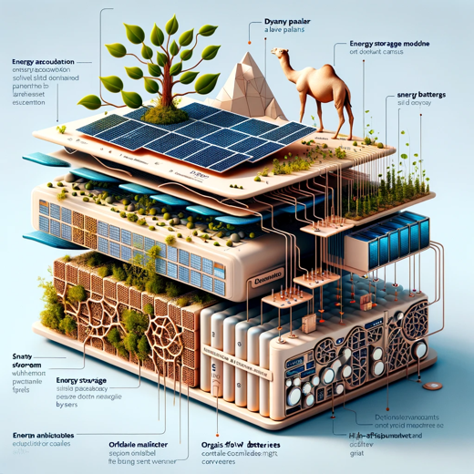

Here's the visual concept diagram for the energy harvesting device based on your requirements and the bio-inspired design approach. This diagram illustrates the integration of the three key modules: Energy Accumulation, Energy Storage, and Energy Utilization, along with their respective bio-inspired aspects. It highlights the compact and efficient design, making it suitable for urban environments.